**Babalwa Mpunyuka -Practical Activity 6**

[babalwampunyuka@womentechsters.org](mailto:babalwampunyuka@womentechsters.org)

1. The browser is running on HTTP version 1.1. The server is running on version Sucuri/Cloudproxy\r\n. This information is found on the Hypertext Transfer Protocol panel.

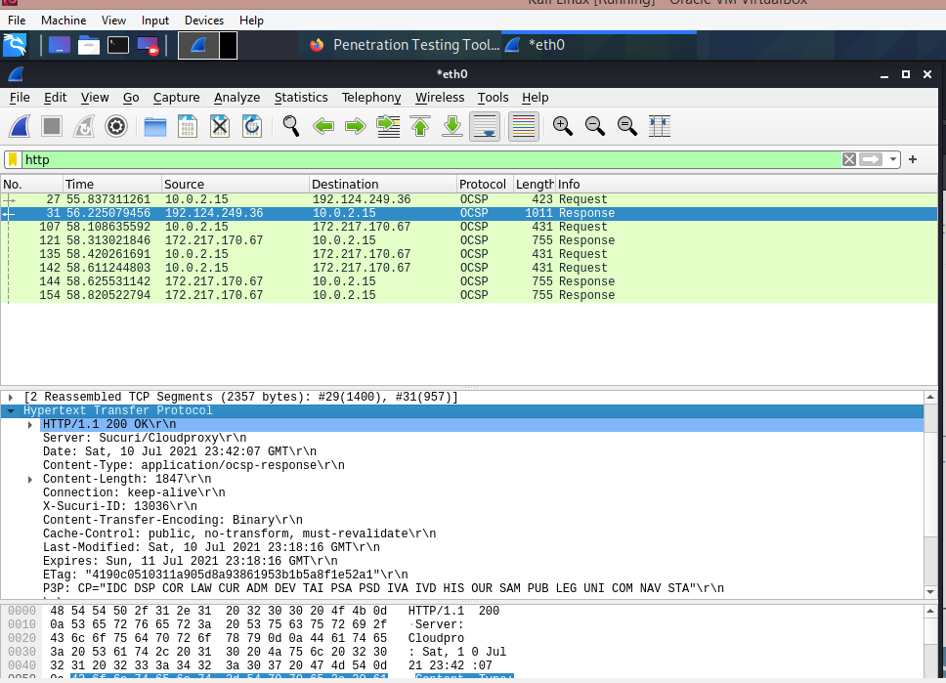

1. The browser indicates that it can accept the English language. In the captured session, the browser also provides information about the host, content-type and the date of the session.

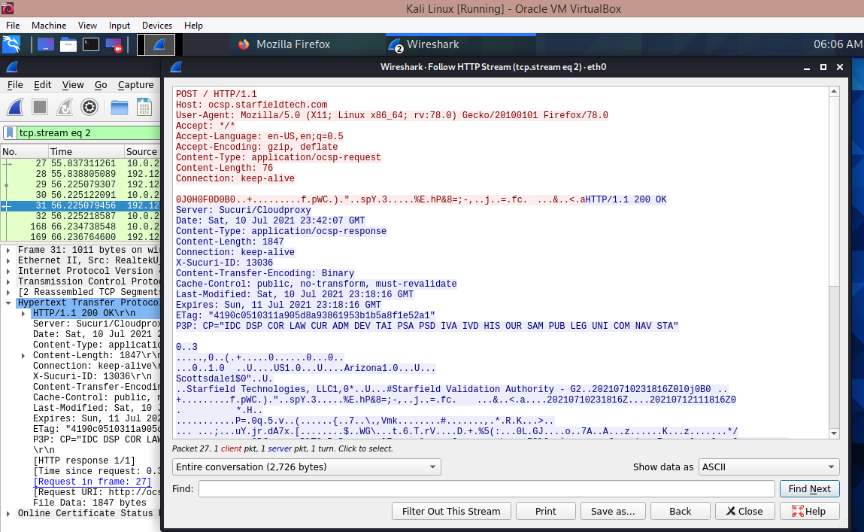

1. The IP address of my computer is 192.124.240.36 and the IP address of the server is 10.0.2.15 .

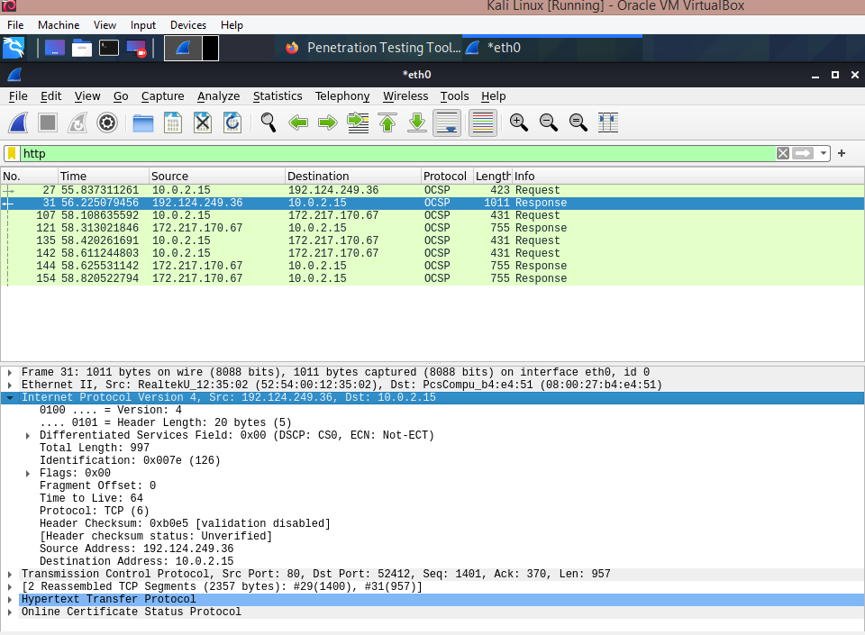

1. 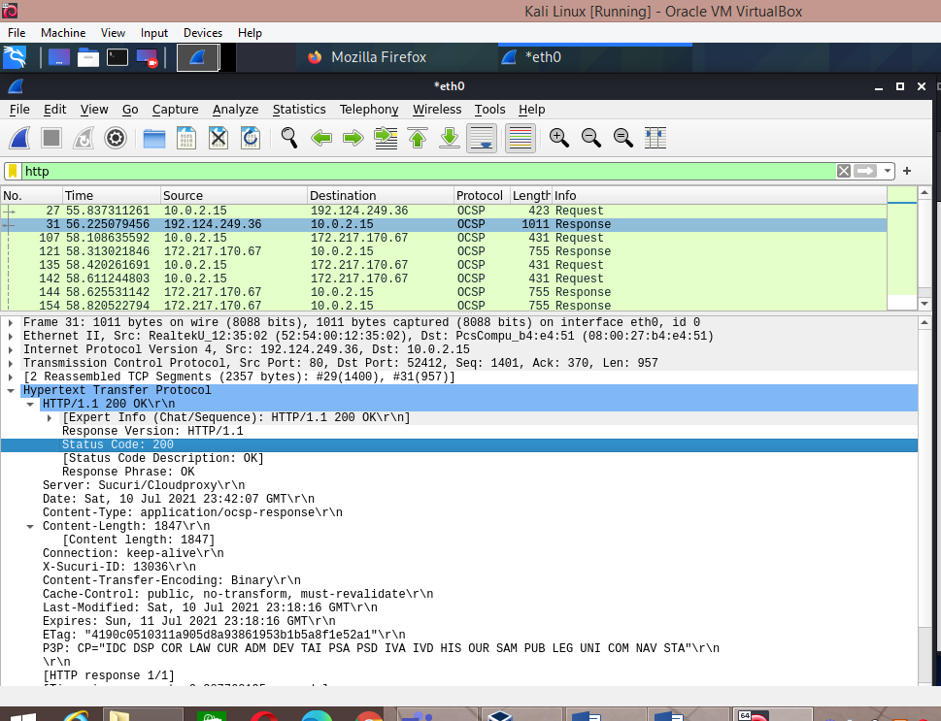The status code returned from the browser to the server is 200. This information is available by clicking on the Hypertext Transfer Protocol.
2. 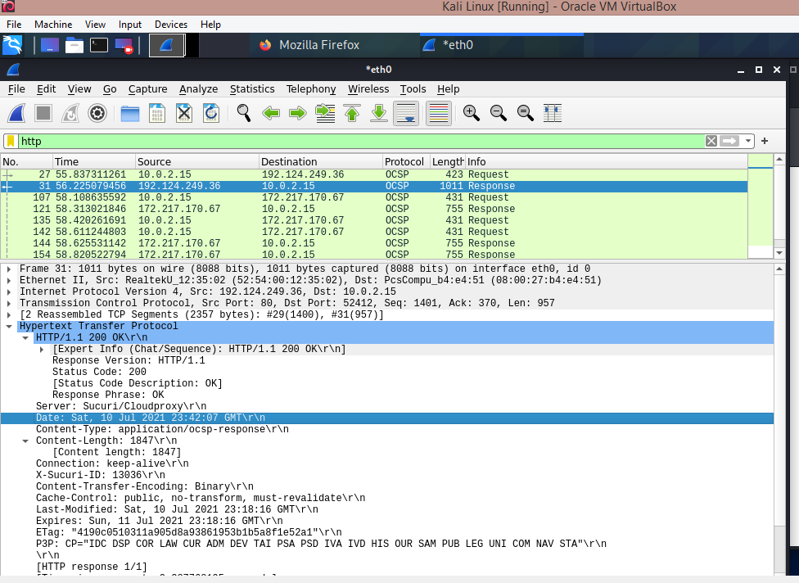The HTML file was last modified on the 10th July 2021 at 23:42 pm.

1. The number of bytes returned from the browser is 1847 bytes as displayed at the bottom of the captured session.

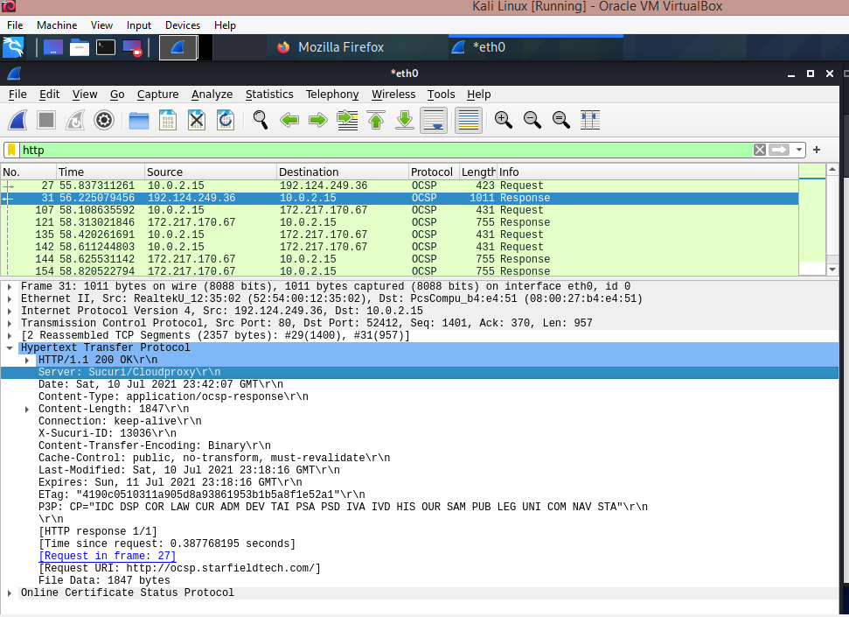

1. No. There are not any http headers within the data that are not displayed in the packet-listing window.